CSE 406

Computer Security

Project Design Report

**DoS attack to the DNS server (using spoofed IP address)**

Name : Abdur Rahman Fahad

Std ID : 1605069

Group : 02

Lab Group : B1

Department of Computer Science and Engineering

Bangladesh University of Engineering and Technology

**Definition of the attack**

DoS attack (Denial-of-Service attack) is a cyber-attack in which the perpetrator seeks to make a machine or network resource unavailable to its intended users by temporarily or indefinitely disrupting services of a host connected to the Internet. Denial of service is typically accomplished by flooding the targeted machine or resource with superfluous requests in an attempt to overload systems and prevent some or all legitimate requests from being fulfilled.

Here we will attack the DNS (Domain Name Server) using spoofed IP address. We will perform the attack by sending lots of meaningless DNS query to the DNS server.

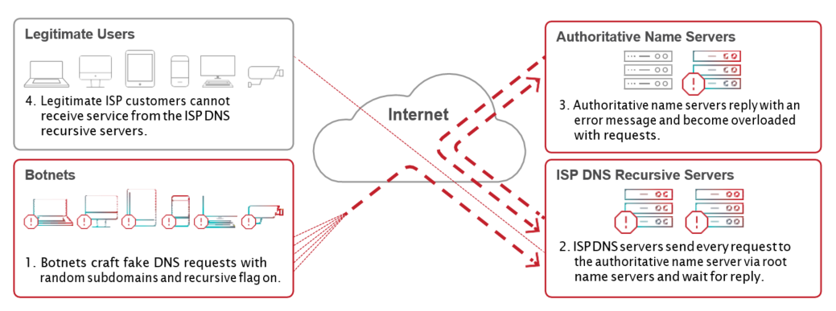

Figure : Topology Diagram of the attack

**Timing Diagrams**

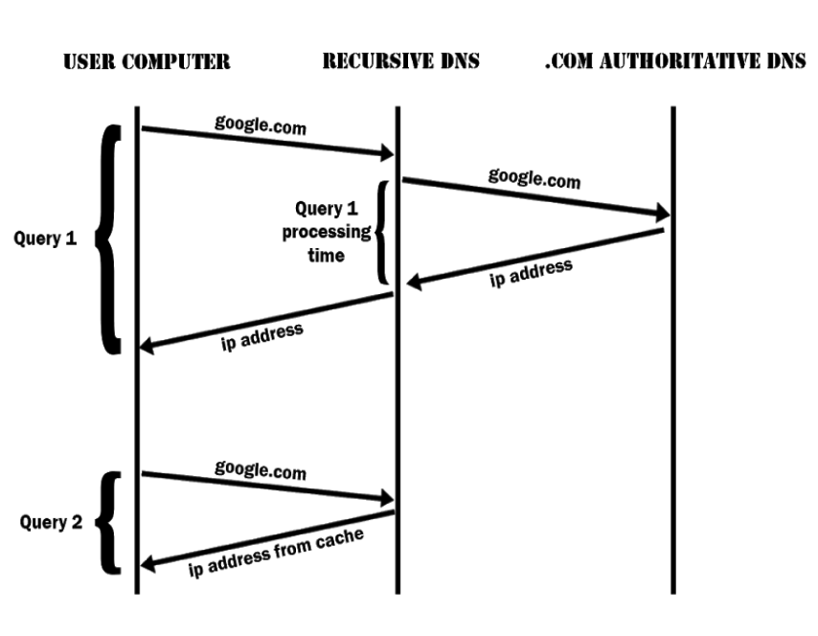

Figure : Timing Diagram of a DNS Query

**ATTACKER PC** **RECURSIVE DNS .COM AUTHORITATIVE DNS**

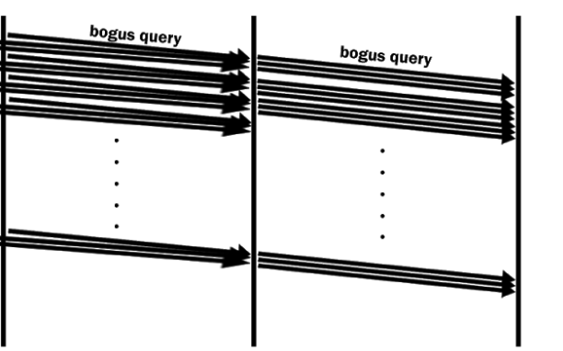

**CACHE FILLED WITH**

**BOGUS REQUESTS**

Figure : Timing Diagram of a DOS Attack on DNS Server

**Attack Strategy**

* We’ll be using a local DNS server, which we’ll attack. We’ll configure a custom DNS server with a tool called Bind9.
* We’ll flood the server with bogus DNS queries with unlimited UDP requests through our script.
* We’ll change our IP continuously with the help of our script.
* We’ll make our own packets for the DNS queries in which we’ll set IP header as we wish, thus attack with spoofed IP will be possible.
* Thus the DNS server will run out of resources and any legit user will not be able to use DNS server.

**Packet details and IP header modification**

A standard DNS query packet looks like this,

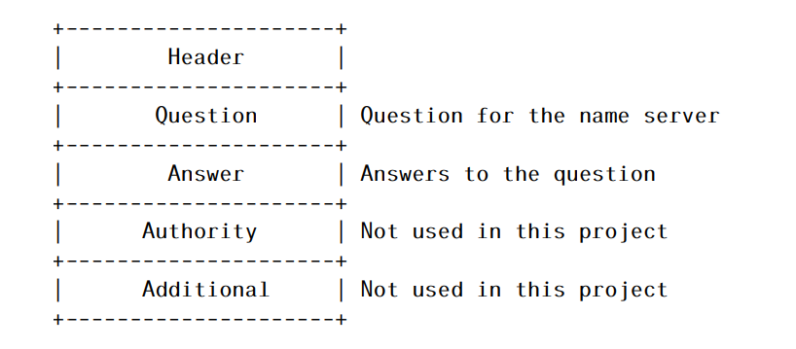

Figure : DNS Packet Structure

DNS packets have a header that is shown below.

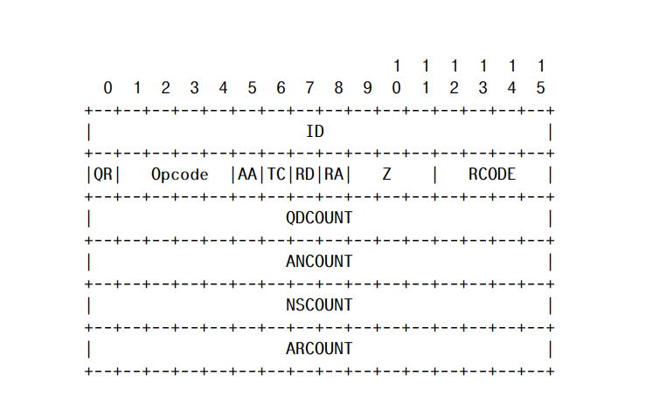

Figure : DNS Packet Header Structure

A DNS question has the format

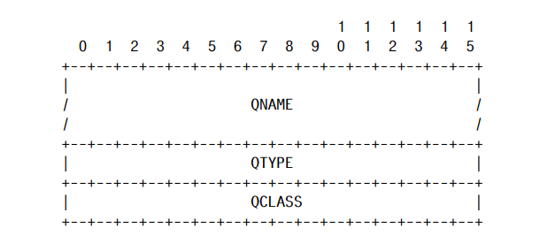

Figure : DNS Question Structure

IP Header has the following format

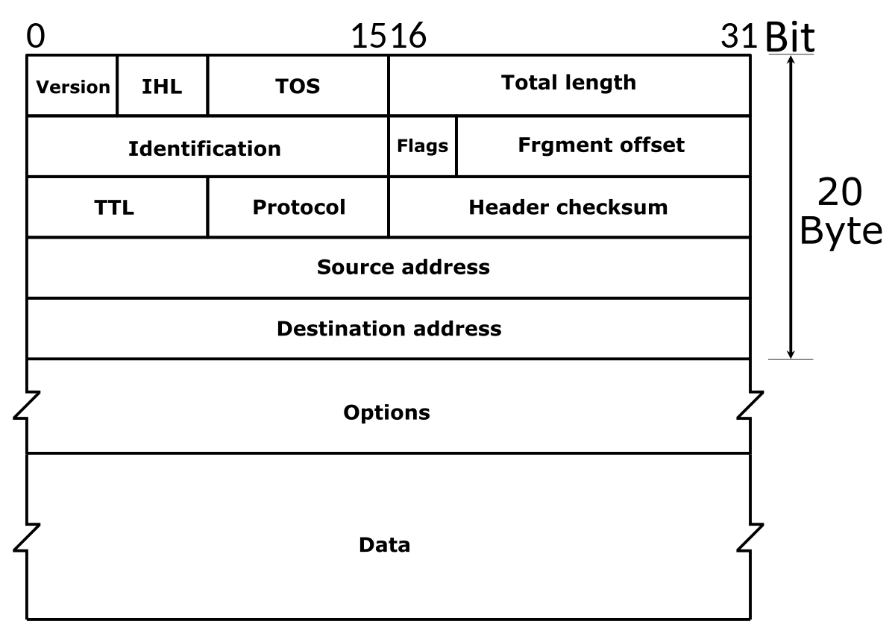

Figure : IP Header Structure

We’ll modify the Source Address in the IP header to implement spoofed IP address.

**Justification**

We will send bogus queries to DNS Server with a spoofed IP address in the source IP address field of IP Header. It’ll fail to find a valid entry in cache and so, the DNS server will send the query to authoritative DNS Servers and wait for the result, which will also eventually be failed.

By doing this with many infinite loop and many more requests than usual, eventually the cache of DNS server will be filled with bad requests. This way, it is possible to flood the targeted DNS and the server will deny any further service from any legit user and our attack will be successful.